Professor Hyacinth Miller
Department of Africana Studies - Conklin Hall 303
hyacinth.miller@rutgers.edu
Student Support hours hours: Wednesdays

The Caribbean in the 21st Century – Challenges and Opportunities
May 17 – May 24

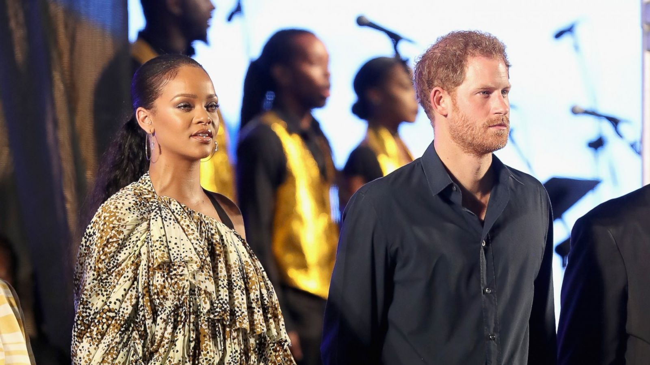

About This Course - Barbados

As the 21st century develops, the Caribbean continues to be central to global debates about a plethora of “hot button” issues. This course will provide you with a week-long interactive learning experience that offers insight into the ways that a Caribbean small island developing state serves as a microcosm of contemporary global challenges and opportunities. Some challenges and opportunities include reparations, environmental justice, women in leadership, and of course, discussions about Rihanna and the Royals. As part of this project, participating students will stay on the UWI campus, engage in lectures with local experts and be in conversation with their UWI peers that we hope will instigate further intellectual curiosity in the subject matter.

This course will also serve two functions: (1) provide you with the necessary tools to help analyze and explain some aspects of Barbados, Caribbean and African Diasporic socio-political history; and (2) serve as a foundation for more specialized coursework in the Department of Africana Studies.

Africana Studies Mission Statement

Course Learning Goals

Course readings, activities, and assessments will be guided by the following learning objectives:
- Explain the historical significance of Barbados in the Transatlantic Slave Trade, and its emancipation and independence efforts
- Explore the ways that Barbados has retained African cultural practices and the contemporary articulation of these practices in everyday life
- Analyze the role that Barbados has and continues to employ in mediating our understanding of the Caribbean, the formerly colonized Americas, Europe as colonizing instigators and the Black Diaspora
- Evaluate the ways that Barbados’ contemporary environmental realities have impacted global climate justice efforts
- Examine the role that Barbados and CARICOM have played in broadening global reparations demands

Prerequisite:

Any course that has a substantial engagement with the Caribbean, especially Intro to Caribbean Studies, and coursework concerning the Atlantic Slave Trade, European empire-making, pre and post-colonial African states, and contemporary discussions that involve people of African descent in the world.

Course Grading Breakdown & Assignments

1. Social Media Engagement……………..…………......................20%
2. Site Participation ……………..……………………………………25%
4. Group Conversations………………………………………………25%
5. Final Journal…………………………………………………………30%

Course Grading Scale

90…100+ | A
87…89.9 | B+
80…86.9 | B
77…79.9 | C+
70…76.9 | C
65…69.9 | D
0…64.9 | F

Late Submission Policy - No late submissions accepted.

Academic Integrity

This course follows Rutgers University policies relating to Academic Integrity. Rutgers University expects students to maintain the highest ethical standards. The consequences of academic dishonesty, including cheating and plagiarism, are very serious. Rutgers’ academic integrity policy is here Academic Integrity for Students. Violations will be reported and enforced according to this policy.
Use of external website resources such as Chegg.com or others to obtain solutions to homework assignments, quizzes, or exams is cheating and a violation of the University Academic Integrity policy. Cheating in the course may result in grade penalties, disciplinary sanctions or educational sanctions. Posting homework assignments, or exams, to external sites without the instructor's permission may be a violation of copyright and may constitute the facilitation of dishonesty, which may result in the same penalties as plain cheating. Plagiarism means copying another person’s written work and presenting it as your own. This covers all submitted work in this course. The University takes plagiarism very seriously as do I.

The department REQUIRES that the following honor pledge is written and signed on every exam, paper, or other major course assignment that is submitted for grading:

“On my honor, I have neither received nor given any unauthorized assistance on this examination (assignment).”

Dropping or Withdrawing from the Course

To drop or withdraw from this course, it is not sufficient to stop posting assignments or contributing to discussion. You must do so formally through the Office of the Registrar. If not, I must assign you an F grade at the end of the semester.

Required technological skills - Ability to use Canvas, a video recorder, social media and Microsoft Word

Required equipment - Computer, Internet access, webcam with microphone OR headphones with microphone; software that can save a file in Microsoft Word, a tangible journal

Videos and Websites

Any required films and videos will be available on Canvas. There is no charge to view any films contained in the Rutgers Libraries. Full versions of many of the films shown in class are available in the Rutgers Media Library - Rutgers Libraries

Protecting the intellectual property of students & instructors

Almost all original work is the intellectual property of its authors. These works may include syllabi, lecture slides, recorded lectures, homework problems, exams, and other materials, in either printed or electronic form. The authors may hold copyrights in these works, which are protected by U.S. statutes. Copying this work or posting it online without the permission of the author may violate the author’s rights. More importantly, these works are the product of the author’s efforts; respect for these efforts and for the author’s intellectual property rights is an important value that members of the university community take seriously.
For more instructions on copyright protections at Rutgers University, refer to the Rutgers Libraries.

Changes to course schedule:
I will adjust the course schedule, required assignments or readings to provide the best learning experience possible, so this syllabus may not be the final version

Selected Course Readings/Excerpts
Lillian Guerra. March 2014. “Why Caribbean History Matters.” Perspectives on History

European Encounters, The People Who Greeted Columbus, The Religion of the Taino People, The Indian Monarchs - The Dominican Republic Reader_Part 1.pdf
Bellegarde-Smith P. (1990). “The Haitian Revolution (1791-1806): Economic and Social Dynamics.” Haiti: The Breached Citadel. Westview Press.
Wendy C. Grenade. “CARICOM: Coming of Age?” Jean Monnet/Robert Shuman Paper Series. Vol. 7. No. 4. April 2007. University of Miami Florida European Union Center.
Race, Rights & Reparations on The Rock Newman Show
.
CARICOM Reparations Commission –
- http://caricom.org/jsp/pressreleases/press_releases_2013/pres285_13.jsp
- http://www.jamaicaobserver.com/news/Int-l-reparations-conference-ends-on-high-note_18754992
- https://www.npr.org/2023/01/07/1146807623/barbados-reparations-britain-caribbean

Du Bois, C. (2011) Caribbean Migrations and Diasporas. In S. Palmié and F. Scarano (eds.) The Caribbean: A History of the Region and Its Peoples. Chicago, IL: The University of Chicago Press, pp. 583-596.
.
Eric Williams. From Columbus to Castro: The History of the Caribbean 1492-1969. Chapter 28
Video clip, President Ronald Reagan news conference on Grenada https://www.c-span.org/video/?101120-1/reagan-news-conference-grenada-invasion

Jamaica Kincaid, 1988. A Small Place.
LaBennett, O. (2017). [Review of the book Rihanna: Barbados World-Gurl in Global Popular Culture ed. by Hilary McD. Beckles, Heather D. Russell]. ariel: A Review of International English Literature 48(2), 170-173. doi:10.1353/ari.2017.0020.

Jules, M. A., Noh, S., Hamilton, H., Brands, B., Gastaldo, D., Wright, M. da G. M., Cumsille, F., & Khenti, A.. (2015). Spirituality, gender, and drug use among students from one University in Barbados. Texto & Contexto - Enfermagem, 24(Texto contexto - enferm., 2015 24(spe)). https://doi.org/10.1590/0104-07072015001140014

Barbados becomes a republic and parts ways with the Queen

Barbados Itinerary - Tentative

Day 1 – Arrive in Barbados – have in-country orientation and UWI orientation

Day 2 – Visit PEG Farm and Nature Preserve and Sea Turtle Sanctuary – lectures on environment and climate justice

Day 3 – Visit Rum Distillery and St. Nicholas Abbey & Lecture on CARICOM

Day 4 – Visit parliament – Scheduled Check in – Free afternoon tours on Bridgetown

Day 5 – Visit Freedom Village and Newton Burial Ground and lecture on Barbados history and cultural evening event

Day 6 – Island Safari

Day 7 – Last day wrap up, drive by Rihanna’s home and presentations

Day 8 – Depart for Newark

