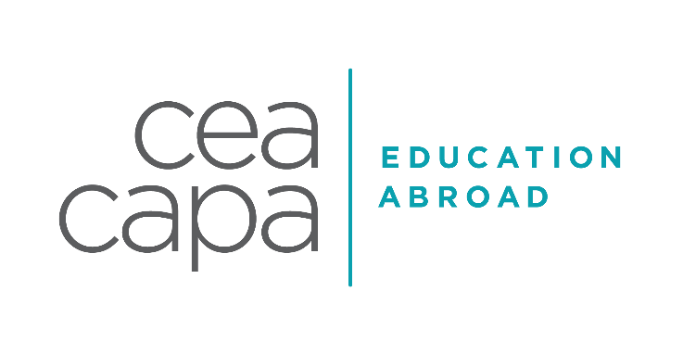

LONDON SAMPLE INTERNSHIP LIST
ENGINEERING

INDUSTRY DESCRIPTION
Engineering opportunities across London are fiercely competitive and many host sites adopt a University Graduate Program. Therefore, undergraduate students seeking an engineering placement must be able to demonstrate a comprehensive academic background related to engineering as well as relevant vocational or extracurricular experience. Due to the nature of the industry and the geographical requirements of many engineering organisations, some engineering opportunities will not be possible in the city of London and opportunities would only be feasible if the student is prepared to travel outside of the city. CEA CAPA has been able to forge a limited number of meaningful opportunities with placements that help to develop engineering skills, knowledge and understanding. Within these opportunities students will need to be able to apply mathematical, scientific, technological and commercial awareness in to practice. As much advance notice of students wanting internships in these areas is required in order for the internship team to start early outreach into opportunities.

EXAMPLES OF PAST PLACEMENTS
Please note that the following sites are a brief cross-section of current CEA CAPA internship host sites and should not be considered as a guaranteed location for your placement. All internship & service learning placements will be dependent upon each individual applicant’s application documents, prior experiences, demonstrated skills and their aspirations and goals.

Imperial College London | The Department of Mechanical Engineering at Imperial College London - one of the world's leading centres for the study of Mechanical Engineering. They have a distinguished tradition of excellence in teaching, research and practice, bringing together internationally leading staff, exceptional students and state-of-the-art facilities. In the past students have worked with PhD students and research teams and worked on the development of wearables.
Lumen Research | Lumen is an innovative 'attention technology' company, using cutting edge eye-tracking techniques to measure the salience and engagement of visual communications. Their expertise in big data research projects mean they can quickly manipulate data to give companies truly useful statistics on viewability, and are able to make solid, actionable recommendations on how clients can optimise their communications. Students have been able to work on data cleaning, dataset investigations and gain exposure to statistical techniques.
WSP | A leading engineering professional services consulting firm. WSP are dedicated to their local communities and propelled by international brainpower. They are technical experts and strategic advisors including engineers, technicians, scientists, architects, planners, surveyors and environmental specialists, as well as other design, programme and construction management professionals. In the past students have been involved in working with the Virtual Design & Construction team, being part of system development and work on marketing communication.
Perfect Storm Media | The goal of Perfect Storm Media is to convert advertising expenses into sales commission on completed sales. Innovation and accountability go hand in hand at Perfect Storm Media, aligning our incentives 100% with the interests of our customers is a powerful proposition that has served us well in a fast-changing online advertising world and the evolving Google ecosystem. Students have been able to be exposed to their software development/automation, work on web development and work on regression analysis.
POTENTIAL PROJECT OPPORTUNITIES
Project opportunities will be dependent upon the current needs within the organisation and the demonstrated skills and abilities shown by each intern. It is imperative to remember that project opportunities will develop over time and throughout internship placements. Projects may include but are not limited to:

Biochemical and Biomedical Projects | Design
Commercial Feasibility Projects | Developing Presentations & Reports
Competitor Screening | Office Administration
Creation of Promotional Materials | Research & Analysis

TRANSFERABLE SKILLS
It is essential to maximise every opportunity within the internship placements. If tasks and duties are approached in a professional manner, interns can take away additions skills and abilities that will be of benefit to their personal and professional development. Transferable skills sets include but are not limited to:

Analytical Ability | Organization
Good Oral & Written Communication Skills | Presentation
Independent Work | Problem Solving
IT Skills | Research
Methodical Approach and Excellent Attention to Detail | Resource and Time Management
Multi-Disciplinary Teamwork

NACE CAREER READINESS COMPETENCIES
Through our pre-departure advising, internship, Global Internship Course and extra-curricular activities, CEA CAPA embeds and works to help students develop the following NACE Competencies:
1. Career and Self-Development: The ability to demonstrate requisite core competencies to develop oneself and one’s career through continual personal and professional learning, awareness of one’s strengths and weaknesses, navigation of career opportunities, and networking to build relationships within and without one’s organization
2. Communications: The ability to receive, interpret and articulate information and ideas clearly and effectively.
3. Critical Thinking: The ability to identify and respond to needs based upon an understanding of situational context and logical analysis of relevant information.
4. Equity and Inclusion: To develop an understanding of oneself, others and to embrace and appreciate diverse and complex perspectives, values and beliefs.
5. Leadership: The ability to recognize and capitalize on personal and team strengths to achieve organizational goals.
6. Professionalism: The ability to acknowledge work environments differ greatly, understand, and demonstrate effective work habits, and act in the interest of the larger community and workplace.
7. Teamwork: The ability to build and maintain collaborative relationships to work effectively toward common goals, while appreciating diverse viewpoints and shared responsibilities.
8. Technology: The ability to understand and leverage technologies ethically to enhance efficiencies, complete tasks, and accomplish goals.

